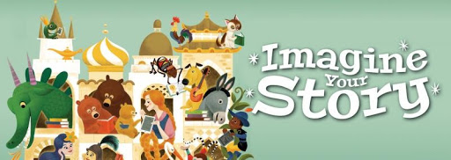

Complete as many of these activities as you can this Summer. Some of these activities can be completed as part of our virtual program series this summer. Please see backside for more information.
When you have completed five in any line, you have BINGO!
Call us at the library, 570-595-7171, to be added to the list for our end-of-summer Virtual Bingo Party!
Summer Learning Quest 2020
Ages 0-5

Read a book about dragons | Recreate a book cover using things in your home | Make a fairy tale collage | Play  Hopscotch | Take a walk
Sing a nursery rhyme | Read a book about animals | Build a tower | Draw a picture of your backyard | Tell someone a fairy tale
Paint a  starry sky | Make a wand or crown | Free  Space | Make a Fairy Garden | Trace your name in sand
Read a book about superheroes | Gallop like a unicorn | Create Your Own Super Hero | Have a puppet show | Make a cardboard monster
Write someone a letter | Read a book backwards | Make a blanket fort | Create a cardboard castle | Dance for 20 minutes
Participate in our virtual programs!
Participate in our virtual summer programs!
Visit our website, www.barrettlibrary.org/summer2020
or call 570-595-7171 for more information about these programs.

Week 1- Imagine Your Story
6/22 - S.T.E.A.M. Challenge: Recreate a Picture Book Cover
6/23 11am - I Love Books Story Time

Week 2 - Unicorns and Dragons
6/29 - S.T.E.A.M. Challenge: Make a Lego Unicorn or Dragon
6/30 11am - Dragons and Unicorns Story Time

Week 3 - Royal Fairy Tales
7/6 - S.T.E.A.M. Challenge: Build a cardboard castle
7/7 11am - Royal Story Time Costume Party on Zoom
Week 4 - Animals
7/13 - S.T.E.A.M. Challenge: Three Little Pigs Building Challenge
7/14 11am - The Three Little Pigs Story Time
7/16 11am - Three Bears Craft-Along

Week 5 - Mermaids
7/20 - S.T.E.A.M. Challenge: Waterslide Challenge
7/21 11am - Mermaid Story Time

Week 6 -Villains and Monsters
7/27 - S.T.E.A.M. Challenge: Cardboard Monsters
7/28 11am - Monster Story Time
7/30 11am - Snow White Bake-Along

Week 7 – Fairies, Gnomes, and Hobbits
8/3 - S.T.E.A.M. Challenge: Make a Popsicle Fairy Bench
8/4 11AM – Small and Mighty Story Time

Week 8 - Sky Above
8/10 – S.T.E.A.M. Challenge: Make a candy constellation
8/11 11am - Starry Night Story Time

Virtual Bingo Party – August 20th 11am

