Read a graphic novel | Recreate a book cover using things in your home | Create a cardboard castle | Write a song about a book you love | Read for 20 minutes
Read for 20 minutes | Take a mindful walk | Read a  “Choose Your Own Adventure” Book | Make a constellation with toothpicks and marshmallows | Read a Fairy Tale
Paint a constellation | Make a fizzy rainbow | Free  Space | Make a Fairy Garden | Read for 20 minutes
Read a fable | Read for 20 minutes | Create Your Own Story Character | Look up at the stars for 20 minutes | Make a cardboard monster
Write someone a letter | Make a fairy bench from popsicle sticks | Build a Unicorn or Dragon using Legos | Read for 20 minutes | Make a meme about the library
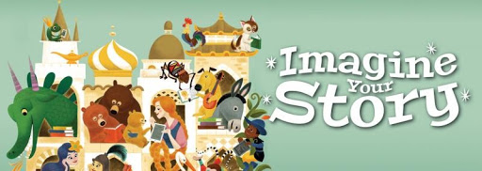

Complete as many of these activities as you can this Summer. Some of these activities can be completed as part of our virtual program series this summer. Please see backside for more information.
When you have completed five in any line, you have BINGO!
Call us at the library, 570-595-7171, to be added to the list for our end-of-summer Virtual Bingo Party!

Summer Learning Quest 2020
Ages 6-11

Participate in our virtual summer programs!
Visit our website, www.barrettlibrary.org/summer2020
or call 570-595-7171 for more information about these programs.

Week 1- Imagine Your Story
6/22 - S.T.E.A.M. Challenge: Recreate a Picture Book Cover
6/25 11am – Choose Your Own Adventure Book Party on Zoom

Week 2 - Unicorns and Dragons
6/29 - S.T.E.A.M. Challenge: Make a Lego Unicorn or Dragon
7/2 11am - Fizzy Rainbow S.T.E.M. Project

Week 3 - Royal Fairy Tales
7/6 - S.T.E.A.M. Challenge: Build a cardboard castle
7/9 11am – Fairy Tale Virtual Escape Room

Week 4 - Animals
7/13 - S.T.E.A.M. Challenge: Three Little Pigs Building Challenge
7/16 11am - Three Bears Craft-Along

Week 5 - Mermaids
7/20 - S.T.E.A.M. Challenge: Waterslide Challenge
7/23 11am – Itty-bitty Beach with Kinetic Sand S.T.E.M. Project

Week 6 -Villains and Monsters
7/27 - S.T.E.A.M. Challenge: Cardboard Monsters
7/30 11am - Snow White Bake-Along

Week 7 – Fairies, Gnomes, and Hobbits
8/3 - S.T.E.A.M. Challenge: Make a Popsicle Fairy Bench
8/6 11AM – Make Your Own Fairy Garden

Week 8 - Sky Above
8/10 – S.T.E.A.M. Challenge: Make a candy constellation
8/13 11am – Constellation Paint-Along

Virtual Bingo Party – August 20th 11am

