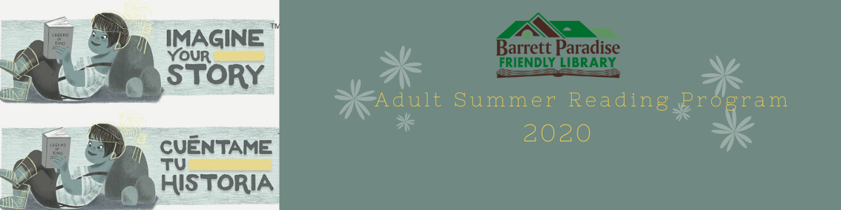
Adult Summer Reading Program 2020
Imagine Your Story Around the World
July 6th – August 8th

Week 1 Brazil: July 6th – 10th
July 6th – Schedule a time this week to pick up a take-home craft from the library. This week, the craft will be Carnival Mask Wall Art. Directions for the project will be with the craft. You can also use your imagination with the supplies given!

July 7th – We will post on our Facebook page the Brazilian fable “Why the Tiger and the Stag Fear Each Other.” Please take a moment to enjoy this story!

July 8th @ 3:00 pm – We’ll be using our trip around the world to try new recipes! This week, we’ll post a tutorial on our Facebook page on how to make the popular Brazilian fish soup, Moqueca.

July 9th @ 6:30 pm – Our Writing Group will be meeting virtually on Zoom at 6:30 pm. If you’re interested in joining, you can contact us via Facebook messenger with your email address or call the library, 570-595-7171, in order to get the link.

Week 2 Greece: July 13 – July 17
July 13th - Schedule a time this week to pick up a take-home craft from the library. This week, the craft will be Asteria’s Captured Stars, using mason jars and glow-in-the-dark paint. Directions for the project will be with the craft.
July 14th – We will post on our Facebook page the Greek fable “The Clown and the Countrymen.” Please take a moment to visit our page and enjoy this story.
July 15th @ 2:00 pm- We’ll be using our trip around the world to try new recipes! This week, we’ll post a tutorial on our Facebook page on how to make Chicken Gyro Bowls.

Week 3 Vietnam: July 20th – July 24th

July 20th - Schedule a time this week to pick up a take-home craft from the library. This week, the craft will be paper lanterns. Directions for the project will be with the craft.
July 21st – We will post on our Facebook page the Vietnamese fable “Love Story of My Chau and Trong Thuy.” Please take a moment to visit our page and enjoy this story.
July 22nd – We’ll be using our trip around the world to try new recipes! This week, we’ll post a tutorial on our Facebook page on how to make the popular Vietnamese dish Pho Noodle Soup.

Week 4 Kenya: July 27th – July 31st

July 27th - Schedule a time this week to pick up a take-home craft from the library. This week, the craft will be Orchid wine bottle vases. Directions for the project will be with the craft.
July 28th - We will post on our Facebook page the African fable “The One-Handed Girl.” Please take a moment to visit our Facebook page to enjoy this story.
July 29th - We’ll be using our trip around the world to try new recipes! This week, we’ll post a tutorial on our Facebook page on how to make the popular dish Kenyan Beef Curry.
July 31st @ 7:00 pm Virtual Trivia Night – Please join us for a fun night of trivia on Zoom. If you’re interested in joining, you can contact us via Facebook messenger with your email address or call the library, 570-595-7171, in order to get the link.

Week 5 Australia: August 3rd – August 7th

August 4th - We will post on our Facebook page the Australian fable “Baloo, the Moon, and the Daens.” Please take a moment to visit our Facebook page to enjoy this story.
August 5th - We’ll be using our trip around the world to try new recipes! This week, we’ll post a tutorial on our Facebook page on how to make the popular dish Australian Meat Pies.

