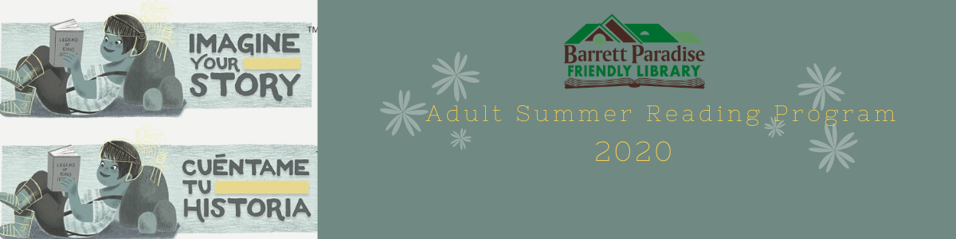

Adult Summer Reading Program 2020

July 6th – August 7th
Finish a Crossword Puzzle | Make a BPFL Take-Home Craft | Listen to an Audiobook | Read a Fable from a Different Culture | Participate in a Virtual Zumba or Pound Fitness Class with Sandra Rivera
Try a New Recipe | Watch a Documentary | Read a Fable from a Different Culture | Take a Nature Walk | Try a New Recipe
Read a Fable from a Different Culture | Participate in BPFL’s Virtual Writing Group Meeting | BINGO | Try a New Recipe | Read a Book on the BPFL YA/Adult Summer Reading List
Take a Nature Walk | Read a Short Story | Color an Adult Coloring Sheet | Join BPFL’s Virtual Trivia Night | Read a Fable from a Different Culture
Listen to an  Audiobook | Read a Fable from a Different Culture | Read a Book on the BPFL YA/Adult Summer Reading List | Make a BPFL Take-Home Craft | Write a Poem
*When you get a Bingo, let us know by messaging our Facebook page or calling the library, (570) 595-7171, with your name and phone number, and we will enter you in a raffle drawing for a gift basket full of goodies. The drawing will be held August 10th. You can get up to five Bingos entered in the raffle. If you cover the entire card, there will be bonus entries! Happy reading!

